Marvellous Infosystems: Angular Assignment 5

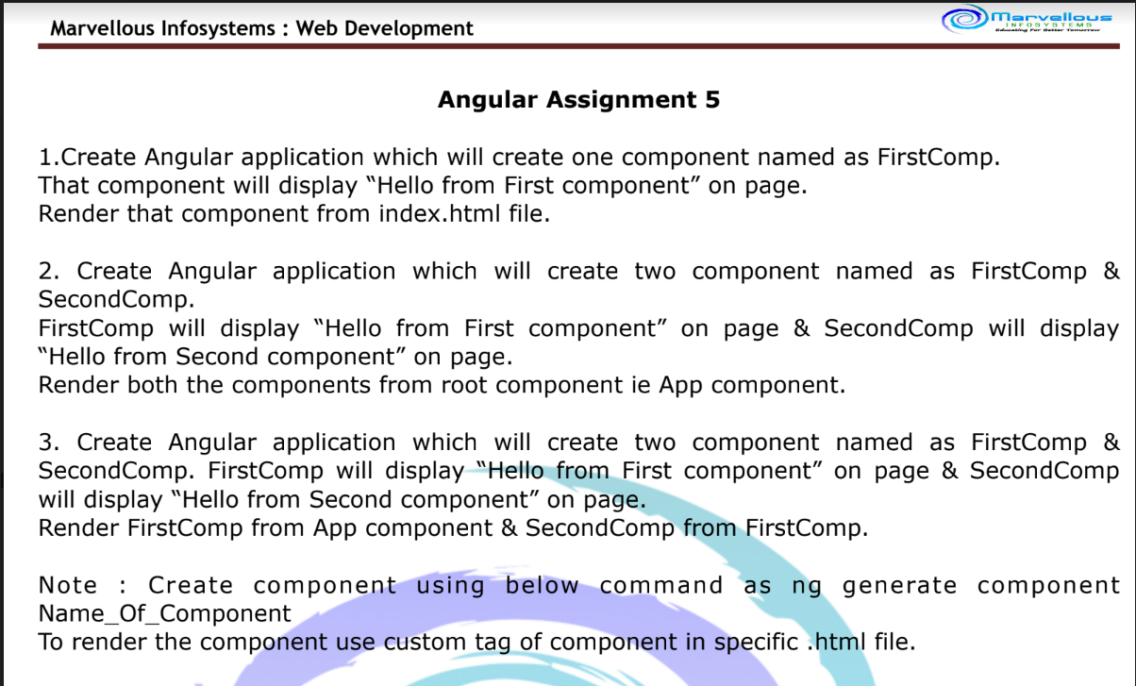

1. Solution:

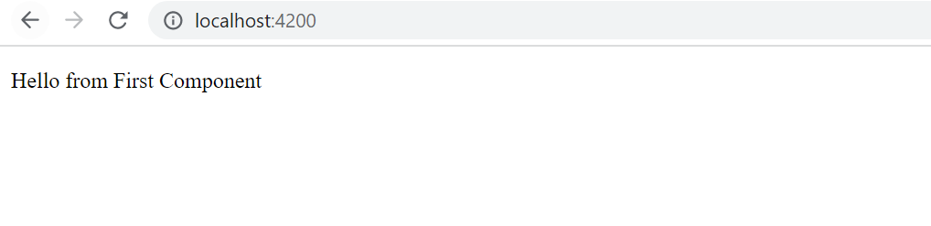

1. Solution:

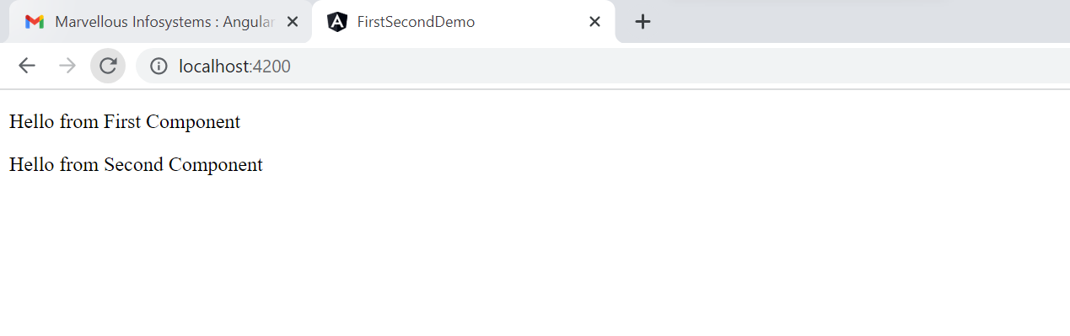

1. Solution:

